18521

CHEN Zi Yuan

Springwood High School

18521

Practical Programming Project



“Title”

Contents

Analysis 2

Problem Identification 2

Stakeholders 3

Client 3

Client Transcript 3

Client Summary 4

Focus Group 4

Questionnaire 6

Results 7

Graphs 8

Focus Group Summary 10

Limitations 10

Hardware & Software 10

Graphical and Audio Design 11

Conditions 11

Similar Solutions (Min of 2) 12

Integral 12

Exam Solutions 13

Popular Solutions (GOLF IT) 14

2 bits of similar code 15

Design Specification, requirements,input requirements, processing/output requirements, storage requirements (pick 10 to be measurable success criteria) 16

Design 17

Explanation 17

Breakdown (2 modules pseudocode, Flowchart for modules, Truth Tables) 17

Top Down Design 17

Explanation of each strand 19

Justification 19

Strands and Modules 19

Bibliography 28

# Analysis

## Problem Identification

Students seem to require a software to help them revise for topic tests and their exams as they may struggle in certain areas. They would need a quiz like software that is also entertaining so they would want to revise and expand on their knowledge and progress through the year. The quiz style will ask them relevant questions and score them so that there is also a competitive nature to this. This will be done for the maths department as maths tend to require practice rather than revising from a book.

By using Unity, I am developing a game which holds attributes from a variety of games to make a game that’s more modernised and more audience friendly because some games are specified to a certain age range. The game that I will be designing will include inertia and friction as it deals with different materials of objects, it will also help my target group be familiarised with SUVAT equations because in my project they will have to hit objects with certain force to move them to a target area.

The Game that I will be developing will have a 2D/3D view where the user will click and drag characters to project an amount of force so that it will travel to the desired target. This mechanic is similar to golf games. The characters will use different materials to slide along the ground giving a change to friction which I used in mechanics. The SUVAT will be implemented as questions on the force and materials they use for the character and the end result will either assist or damage their game. The level will have obstacles so it will stop the characters from moving in that direction.

There will be a round by round system where the rounds will alternate between the Player and the AI team as they try to aim to attack each other. At the end of rounds, it will detect if there will be any damage done to any charters and detect if any will die, which will remove the character from the current level.

There will be problem solving tasks for the clients to solve and help them advance in the game and in their skill. The problem can be solved by using computational thinking such as abstraction, simulation and algorithms.

* By using simulation within the game, it can help solve the problem by giving the client visual guides on the objects movements and forces that will have an effect on the objects. They will also be able to visualise the force that they entered and the effect it has on the object. Simulation is a good way for people to see and understand SUVAT and friction in an environment rather than on pen and paper which will help some people remember and understand the effects of friction and the uses for SUVAT equations.
* The problem is also suitable by abstraction as the only information they will need is variables for the SUVAT equations which they will need to identify and change to get the desired outcome that they would want. The game will not include other variable that may affect friction and SUVAT equations such as wind, density weather and other variables that would not be of use. The only variables that will be affected and changed will be the basic needs for friction and SUVAT equations like gravity, speed, time, velocity, distance etc.
* Decomposition and Algorithms, the problem can be broken down into smaller algorithms so that the jobs will be easier to complete and will not be too complicated to understand. The equations can be split up so that each algorithm will only focus on a certain aspect which will mean less errors are likely to occur. The algorithm will be able to be reused for multiple purposes along the way so that there won’t be any unnecessary code that doesn’t need to be repeated.
* Theoretical approach is also useful because there is a use of prediction of how speed the ball is going and how far you would have to travel. I.E. If the ball was x distance away, then there would need a y force to get it into the target area for it to be successful so theoretical approach for games will be suitable for my project.

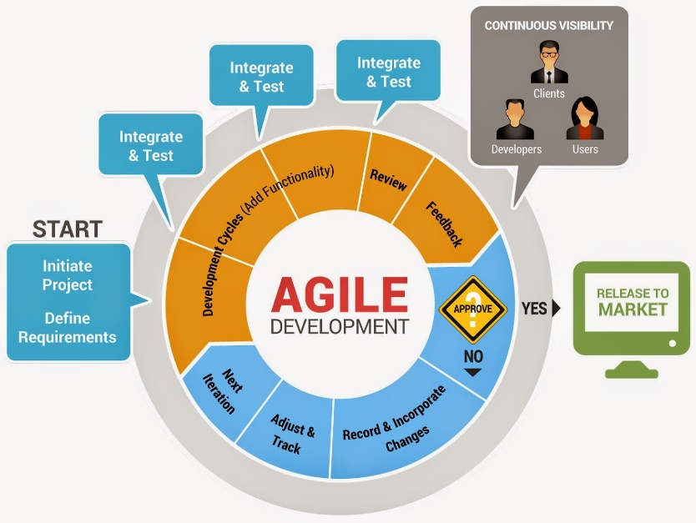Agile life cycle is the system life cycle that I’ll be using for the project as it will have regular inputs by the clients and focus group which will allow me to make adjustments and improvements along the way so that the final product will satisfy the stakeholders (client and focus group). Agile is also useful due to a limited time frame for the project. Figure 1[1]

Figure 1 Agile Life Cycle

## Stakeholders

My stakeholders will be physics or maths students who are struggling with the understanding of Mechanics and memorising the equations. They would be the focus and will have an input to the project along with the teacher who is my client. They will be able to have input to help suit the project to their needs which will assist them in their subject. There will also be a scoreboard system within the project so the students and teachers can view their progress throughout.

To collect information, I will be interviewing and questioning both the client and focus group throughout the project to get their involvement and any additions/change they would like.

### Client

My client is a maths teacher (Mr Levy) who teaches both the high school students and A-level ones including teaching mechanics which I aim to provide support. I have asked him a series of questions to help me find the main problems that people struggle with and what I should involve within the project so I can adapt my project to these ideas and any additional ideas he may like to see within my project.

### Client Transcript

**What do you see your students struggling with in mechanics?**

Most of them understand the basic use of the questions with the equations. But some do struggle with memorising the equations and more complex use of them.

**What method of teaching did you use for this?**

I teach them by using examples and giving them worksheets to progress through so that I can see their progress throughout.

**What would you like to see within the game?**

A game should be fun and entertaining but, in this case, it should also has parts of education.

**Should it be multiple choice answers?**

Yes, it should as it wouldn’t be too difficult for them to solve and it gets them use to the questions**.**

**How should the quiz be laid out?**

With a question and at least 3 multiple choice answers.

**How many questions would you recommend for each level within the project?**

At least 3 which are similar to the actual solution so guess work wouldn’t be possible and it would require them to actually think.

**How focused on the questions should the game be?**

They should be relatively focused so after each turn or something similar but they shouldn’t be bombarded by questions.

**What your views of a point system and maybe a teacher’s section?**

Point system is a great idea as it would be competitive which will encourage some to get better scores so they will be revising more. A teacher’s section would be useful so we can check on their progress and add additional, maybe personalised questions for each student individually.

**Is music a good idea for the game?**

It would be nice for the students as it wouldn’t be too stressful for them but it would have to be lyric less music and calming so it doesn’t distract them too much.

**What other resources have you used for revision purposes for the students?**

Mostly Worksheets and I demonstrate the question and how it’s done. I allow students to find me and work through areas they’re stuck in.

**How difficult should the questions be?**

Should have a range of questions for different level students.

### Client Summary

From the client interview, I have concluded that I should use a quiz style setup to ask questions and have it been multiple choice so it wouldn’t be too frustrating for the students. I should therefore have a question for each round so it’s not too common and a leader boards so teachers and students can compare scores and see if they have improved throughout the use of the game. I’ve gathered that there should be a bank of questions for each difficulty so that it will be more beneficial for different level of students. The points for these will change relative to the difficulty of the questions.

Therefore, from this first interview I have gathered how my questions should be laid out, features such as leader boards and different difficulty for the levels and questions for the students. Also, I will have to include a way for the teachers/parents to access the questions and view progress so they can check on them or add more questions.

### Focus Group

My Focus group consists of 17-18 aged physics/maths students who do mechanics in either of their chosen subjects. They will be testing and using the game to see if their scores will improve from the effect of the game. It will help them learn and develop their understanding of mechanics from the use of my project. Their performance can be recorded and they will have an input to the project by giving me feedback and any pros and cons that they may want adjusted.

The project will be designed for their use out of lessons most of the time on a computer or tablet as it will provide them with support outside of lesson if they would need help. This could be set as homework by the teachers so that they can check on their progression and the questions can be tailored to each student. I don’t believe this should be set in lessons as the software doesn’t teach them how SUVAT works but only how to apply it. As it will be used outside lessons, it will provide extra help to those who need it and a competitive way for them to play and improve with.

### Questionnaire

### Focus Group Questionnaire

This Questionnaire will ask questions on SUVAT and Games, please answer sensibly and circle the answers intended for the categorical questions.

**Are you confident with the use of Friction and SUVAT equations?**

Great / Good / Alright / Needs improvement / Bad

**What method do you find best for learning this? (Can circle more than one)**

Worded Examples / Diagrams / Practice / Explanation

**What do you struggle with most about this?**

Input response here

**Do you revise school work, if so how many hours a week?**

Less than 2 / 2-5 / 5-8 / 8-10 / More than 10

**Do you actively play Computer Games, if so how many hours a week?**

Less than 12 / 12-18 / 18-24 / 24-30 / More than 30

**What genre is your favourite, e.g. Simulation, Action, Adventure, Survival, Indie. (Name up to 3)**

Input response here

**What resolution do you like a game in?**

1600x900 / 1024x768 / 1280x720 / 1920x1080 / Other _______

**What do you like within a game, e.g. art style, music, characters?**

Input response here

**What do you dislike within a game?**

Input response here

**What features do you like within a games? (E.g. Multiplayer, a Workshop etc.)**

Input response here

This is the end, thank you for finishing this questionnaire.

The questions I have asked to my focus group will be used to help me decide what people would most want as a revision resource and it’ll be more tailored to the focus group which are A-level mechanics students. I have chosen questions such as the time of gaming and revision so that I can compare the amount on average students do and if their gaming may affect this amount.

The first few questions are used to figure out what they’re stuck on in mechanics and what they prefer to learn by. The last few questions are used to find out what kind of games are preferred and what my project should be tailored towards. Also, it will give me ideas and suggestions of what to include within the game.

### Results

**Are you confident with the use of Friction and SUVAT equations?**

Great – 2 Good – 4 Alright – 2 Needs Improvement – 3

**What method do you find best for learning this?**

Worded Examples – 6 Diagrams – 0 Practice – 4 Explanation - 4

**What do you struggle with most about this?**

The response has ranged from nothing to everything with some being more specific like rearranging or memorising the equations and which to use in certain questions.

**Do you revise school work, if so, how many hours a week?**

4 people do less than 2 hours, 4 people does between 2-5 hours, 2 do between 5-8 and 1 does more than 10.

**Do you actively play Computer Games, if so, how many hours a week?**

2 play less than 12 hours a week, 2 play between 12-18 hours, 1 play between 18-24 hours and 6 people play more than 30 hours a week.

**What genre is your favourite, e.g. Simulation, Action, Adventure, Survival, and Indie?**

RPG – 1 Adventure – 3 Strategy – 6 Action – 3 FPS – 3 Survival – 1 Platformer – 1 Other – 4

**What resolution so you like a game in?**

1920x1080 – 6 1280x720 – 2 2560x1440 – 1 Other- 2

**What do you like within a game, e.g. art style, music, characters?**

Music – 1 Good Art Style – 6 Character Design – 2 Challenge – 3 Combat – 1 Other - 7

**What do you dislike within a game?**

Lag/Ping – 3 Loading Times – 2 Bad Music – 1 Bad Characters – 1 Cut Scenes – 1 Other – 6

**What features do you like within a game? E.g. Multiplayer, a Workshop etc.**

Customisation – 5 Multiplayer – 5 Optional Mouse – 1 Secrets – 1 Leader Boards – 1 Other – 4

### Graphs

The majority of the features pie chart suggests that from my focus group they would like customisation and multiplayer with other suggestions like leader boards and secrets/Easter eggs in the game. There are no mentions of other ways of controlling like a joystick or controller so the focus groups preference are mouse and keyboard. This suggests that the game should be able to work in tablets, laptops and PCs.

The trend to the data between revision and gaming is that the more revision people do (multiplied by 5) the less games they play. This graph suggests that more people are focused on gaming rather than revising. This means that my project in theory should be helpful as it creates a game for revision so the more, they use it, the more they’ll also revise which should be able to help them through their lessons and work.

There seems to be lots of dislikes my focus group have within a game which I will have to try to avoid and/or fix. The major things that could have an effect to my project would be the lag/ping, music and loading times as these are most likely to be problems in my game so I will have to work on these so that the problems won’t appear. Other dislikes like characters and cut scenes are irrelevant to my game as they will either not be included within the game or kept to a minimal.

The majority of the resolution pie chart suggests that most people would prefer a 1920x1024 resolution for the game and not the others. This seems reasonable as most screens should be able to run 1920x1080 for this game. Screen size like 1280x720 would work however there is less demands for it and larger screen sizes like 2560x1440 wouldn’t work as it will need a high spec pc to be able to work and detailing within the game will need to be high. Therefore, a 1920x1080 is most fitting.

In this pie chart, it shows that most people have different tastes in genres and some don’t mind what genre the game is as long as it’s playable and fun. However there does seem to be a larger amount of people preferring strategy, action and adventure. Within these, strategy links in with their option choices and most of my focus groups has picked maths, physics and/or IT so there are lots of problem solving. Therefore, as they seem to enjoy problem solving then strategy is the best options for this.

### Focus Group Summary

From the questionnaires I have gathered that the basic must need requirements for my game should be:

* Screen size of 1920x1080
* Customisation of characters and menu settings
* Good Art style
* Challenging strategy game
* Leader board
* Mouse and keyboard input

Then preferable requirements for the game are:

* Background music
* Easter eggs

### Maths Questions

## Limitations

### Hardware & Software

The requirements to be able to run Unity may not be reached by some computers. The computers at most school uses windows 7 and are linked to the school’s network so the hardware and software that will be needed to run unity well is listed below:

Hardware needed:

* Windows 7 or higher so there can be an OS and visuals for people.
* Graphics card with DirectX 10 shader model 4.0 capabilities. Needed for the OS.
* CPU with SSE2 instruction set support
* 250GB Hardware or better, so space is provided to store the project and other required software.
* At least 1 GB RAM, so software and the OS can run quickly.
* At least 1 GHz Processor, instructions can be executed efficiently.
* Monitor to be able to display the software and graphical parts of the project.
* Mouse to control camera and allow user to input data.
* Keyboard allows users to input data and keys needed.
* Speakers for feedback and music within the project.

Software needed:

* Windows 7 OS+, to provide operating system to run all required programs.
* Unity 3D, used to create program and test the program.

These are the minimum hardware and software requirements that are needed so that the overall program will be able to run. Main ones that have the most affect is, storage as its needed to download the program and software listed but this does not require much. RAM is needed so the program calls resources quickly and if this isn’t reached then it will cause lag as resources won’t be retrieved fast enough which may cause the program or even the PC to crash. This is the same for the processor so that the data and instructions can be passed. The CPU and Graphics card will need to be up to date because the CPU would cause crashes if not up to requirements and the graphics card can cause major frame drops to the program which could render it unusable. Therefore, these are the major hardware that will cause most issues but it is still best to have everything up to what’s needed. Luckily the computers at most schools already reach these requirements apart from downloading Unity which is easy to install.

### Graphical and Audio Design

Due to my project being a game, I will need art and textures so it’s visual attractive for people to play whilst learning. The textures I will use will be from within Unity as they have some free textures, non-copyrighted textures and designs and some custom art made from modelling software and pixel software like voxel. Also, a good layout is needed for the questions on mechanics within the game.

There will also be the need of music so that the user will enjoy the game more and be more focused. The music will be difficult to create and will be lyric less, therefore I will be using royalty free music for my project.

Overall this isn’t likely to affect any of the coding for the program but will affect the users of the program as it will need to be visually intriguing for them to play and learn from. So, I will need time to import art and designs in the program but this will be after all the basis of the program is complete so it runs well.

### Conditions

Time may be a major condition for the project as I will need to layout a timeline of what to do by when as there is a deadline for the project. I will be setting everything that will need to be done in order of what to do and when it should be done with some flexibility in case of bugs or difficulty with some parts. Funding will not be a limitation as the programs are free. The software on the school system and the one that I will be using must be the same versions or issues and bugs may cause delays and problems.

The main condition that will affect the overall product is time management as it needs to be effective and efficient for the program to be finished and refined.

### Time Scale

|  |  |  |  |  |
| --- | --- | --- | --- | --- |
| Activity | Expected time taken (days) | Start Date | End Date | Actual time taken (days) |
| Analysis |  |  |  |  |
| Identify problem and First Draft | 1 | 17/05/18 | 19/05/18 | 2 |
| Find suitable clients and stakeholder | 1 | 20/05/18 | 21/05/18 | 1 |
| Hand Out  Questionnaires and Interview Client | 1 | 22/05/18 | 23/05/18 | 1 |
| Analyse and Write-up | 2 | 23/05/18 | 25/05/18 | 2 |
| Create Graphs and explain | 1 | 26/05/18 | 27/05/18 | 1 |
| Hand Out Maths Questionnaires | 1 | 30/05/18 | 31/05/18 | 1 |
| Final Write up for analysis | 4 | 31/05/18 | 05/06/18 | 5 |
| Establish Criteria | 1 | 07/06/18 | 09/06/18 | 2 |
| Design |  |  |  |  |

## Similar Solutions

### Integral

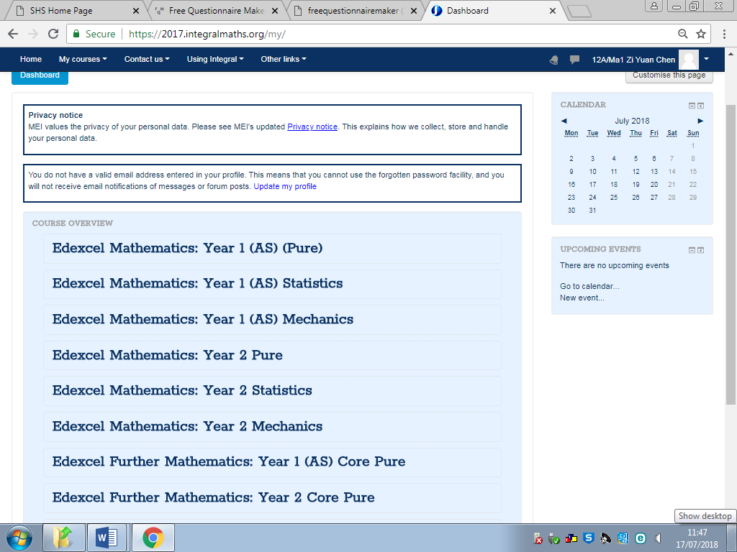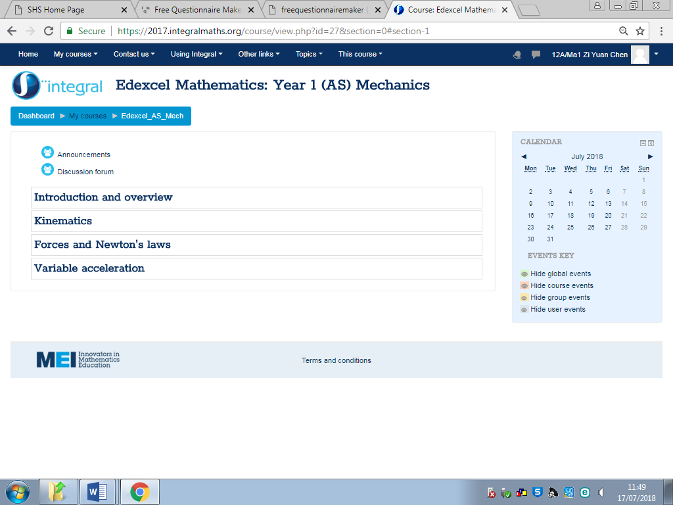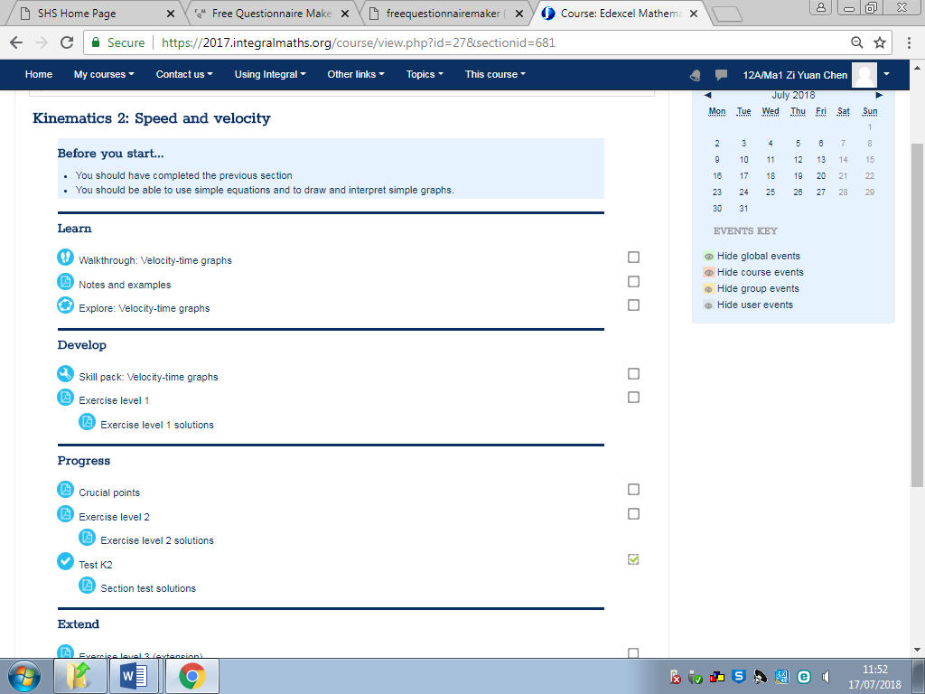Integral is a website which holds information and revision resources for topics in maths. It included resources for mechanics. (Figure 2)[2] By seeing what they have done for the resources I will learn what will be required for it to be educational and any improvements that I may add to my program that will overall improve it.

Figure 2 Course Overview of Entire A-Level

Figure 3 Within the Dashboard of Sub Topics

Shows and displays all topics that have been signed up for and displays it to the students in chronological order. Within that holds each topic from the section and each topic has sub topics so it’s easier to revise parts of it from.

Within each section, its splits further down into smaller topics and within those hold tests, PowerPoints and information to help the students throughout their a-levels.

Figure 4 Walkthrough through a Sub Topic

Their way of assisting students is by having a presentation for each topic of a section with worksheets and examples to work through. They also have topic tests to test the overall knowledge of the topic.

Advantages of this is that it’s a good way if learning as it gives the users the ability to learn through their own pace and it has relevant information and explanations for them to understand everything. (Figure 3)[3] It also contains topic tests for them to test their own ability and has the feature of a teacher being able to view their progress. The site does have a checklist so you can check what parts you’ve completed and what you haven’t. (Figure 4)[4]

However, disadvantages for this is that it’s designed to be broadly used so it cannot be focused on specific users, also they have the same resources so there is a limit to all the work that can be done on the site. There is also the need to have a teacher sign up for the site and apply for each topic that you will be needing.

The ideas that I could use from integral is that it has questions of different levels and assigned to different topics. This will be useful for me so that the correct students will be assigned to the right subject areas and difficulty. They also have a point system to how much work the student achieved which is what I intend to create so that this can track their progress for them and their teachers whilst it being similar to a c=scoreboard for a competitive nature.

### Exam Solutions

Exam solutions is a website that provides users will the necessary information and exam papers and questions for the users to use and practice. There is also quick summaries and explanations that explain the steps involved and how to achieve the right answer. It’s mainly holds past papers and other officially made papers for students to download in each section of the subject so they can practice questions in an actual exam questions to improve their ability.

Figure 5 Shows Course for Entire Year with PowerPoints and Papers

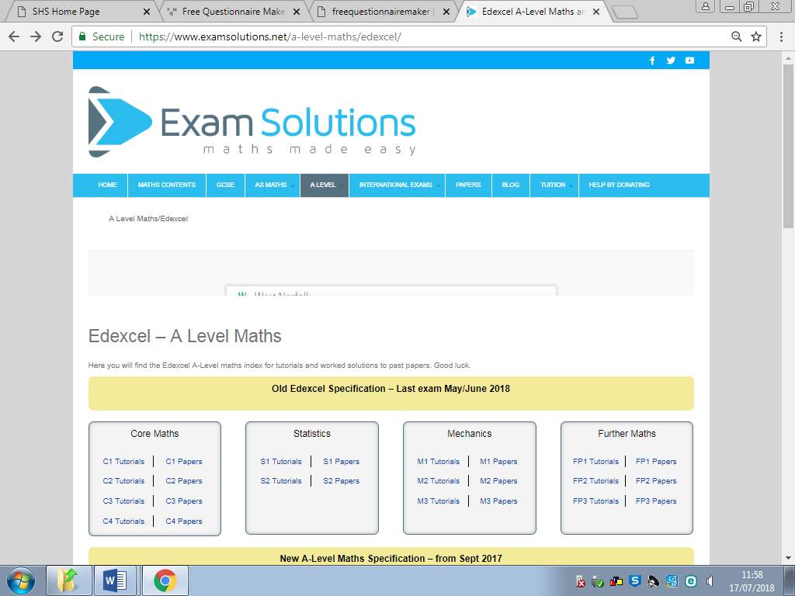

Holds Tutorials for students to study and then papers to practice for each topic.

Advantages of this system is that there is a plethora of questions to go through and it’s very unlikely that the students will run out of practice questions. It assists them in actual exam styled questions and gives them plenty of practice for the questions. (Figure 5)[5]

Disadvantages of this is that the questions are usually similar and can become tedious and boring for the users. There are no incentives for the students apart from getting it right and also even though it has exam solutions, it may not go through all possibilities so if a student is confused, the site will not be able to help.

What I will be using from this is their exam style questions s these are the type of questions that would come up in an exam situation. Also, its plethora of questions so that the students shouldn’t run ot of questions to practice. It contains the questions for them to answer and answers afterwards to assess their own work. This will be implemented into my program so that they can see what went wrong and how to progress through.

### Popular Solutions (GOLF IT)

Golf It is a golfing game for PC and consoles. It’s developed and published by Perfuse entertainment and was released in February 17th of 2017. The game designs focus on real life golf as a digital game but inputting different ideas into it. For example, they have high ramps and loop de loops for the users to pass through to get to the end hole in the least number of strokes. There is also use of obstacles that will require good timing or angle to get pass like logs and the classic windmill for golf. (Figure 6)[6]

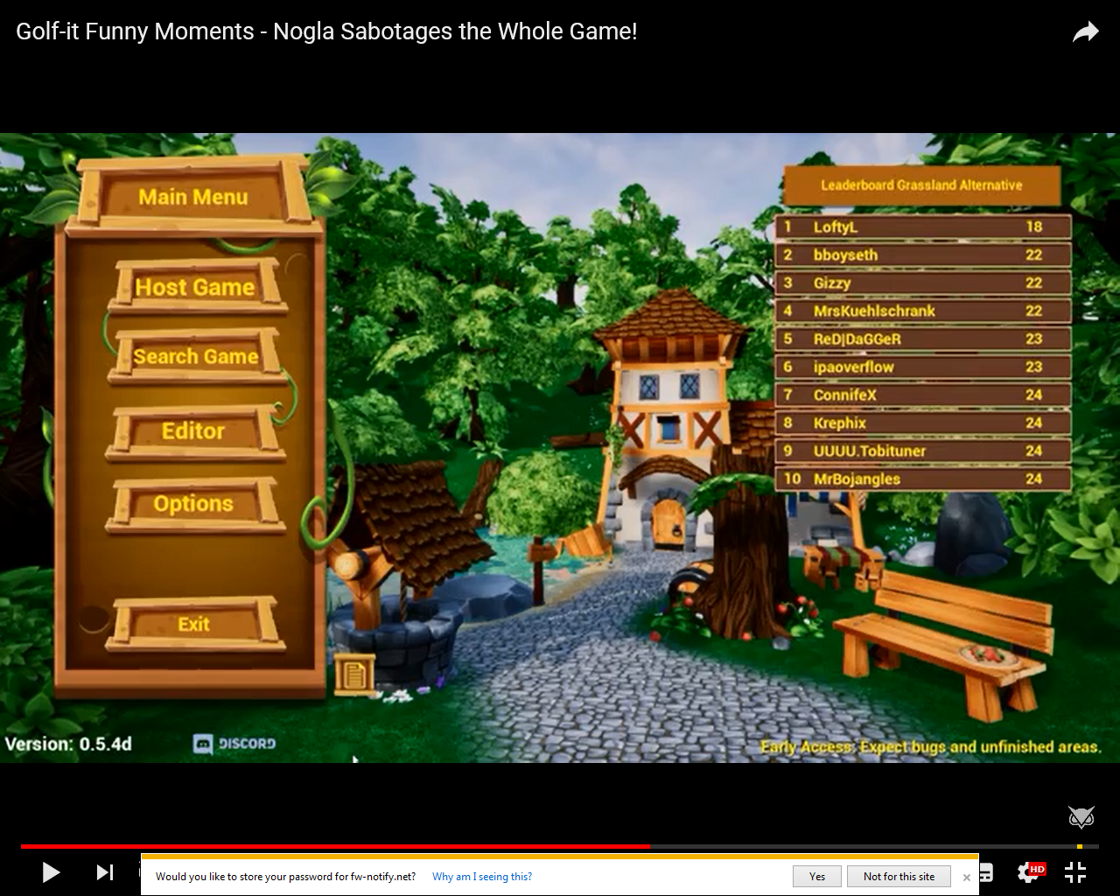

Figure 6 Main Menu for the Popular Game GOLF IT.

Has the menu set up in a good layout with a background image and music, also the leader board is visible on the right of the screen.

They also have special events like Halloween and Christmas versions to add more content to the game and a workshop mode mostly for PC so that users can also design a golf course and publish it the workshops o that anyone with the game can download it. This add lots of possibilities for the game and in theory infinite number of courses. The game also includes multiplayer so that you can play with friends to make it into a more competitive game.

It uses variables such as speed, friction, momentum etc. They use these to create a game version of the real-life golf, the mechanics for the game is hard to master but fun. This is what I hope to achieve for my project so that it can be fun and interesting to play, I will be adapting ideas from this game into my program so that it will be fun and easy to use.

From GOLF IT, I will use ideas such as the game mechanic, menu style and visuals to implement into my program. The game mechanic already includes various variables which is from mechanics in maths however these would need to be adjusted to be more fitting for a maths game. The menu style is simplistic and easy to follow so this is a good example of what my menu will be like. Finally, its visual makes it fun and visually entertaining so it wouldn’t bore people.

## 2 bits of similar code

This sets the variable as an object within the game so it can be affected by forces and other variables.

public GameObject arrowPrefab;

GameObject Arrow;

Vector3 StartPos;

These find the start position of the object and the current position.

Vector3 CurrentPos;

// Update is called once per frame

Updates code every frame per second so faster computer will have this code executed more as fps will be higher.

void Update () {

// If screen is touched

if(Input.touches.Length >=0 )

This if for mobile but I can adapt it for keyboard and mouse inputs.

{

// Make start position

StartPos = Input.GetTouch(0).position;

Debug.Log (Input.GetTouch(0).position);

}

https://answers.unity.com/questions/495616/need-help-with-a-golf-game-script.html

<https://www.codeproject.com/Questions/1214607/Creating-a-quiz-in-Csharp>

int score = 0;

int i = -1;

Sets up the initial variables to be used in the code below.

int a = 0;

string[ ] questions = new string[ ]

{

Stores all questions and answers in different arrays called questions and answers. Also it makes sure that the questions and answers entered are read as string values and not Boolean.

"What is 9 cubed?", "What is 6+3?",

"What type of animal is tuna sandwiches made from?",

"What is 18 backwards?"

};

string[ ] answers = new string[ ] {

"9", "81", "729", "2",

"4", "2", "9", "1",

"zebra", "aardvark", "fish", "gnu",

"31", "81", "91", "88"

Stores the answers that has been received by the user.

};

string [ ] quizAnswers=new string[ ]{"729","9","aardvark","81"};

private void btnStart_Click(object sender, EventArgs e)

{

if (i < questions.Length)

i++;

//txtScore.Text = score;

Displays each question with the 4 options below and awaits for the user’s input as their answer. This is looped every time a question is answers and code below if executed until I is less than the amount of questions in the bank

lblQuestion.Text = questions[i];

radA.Text = answers[a];

a++;

radB.Text = answers[a];

a++;

radC.Text = answers[a];

a++;

radD.Text = answers[a];

a++;

btnStart.Visible = false;

btnStart.Enabled = false;

Different variables and states which is shown and useable for the user.

btnSubmit.Visible = true;

btnSubmit.Enabled = true;

}

private void btnSubmit_Click(object sender, EventArgs e){

if(getSelectedAnswer().Equals(quizAnswers[i]))

This is an IF statement and it checks that the answer that the user has picked is either correct or incorrect. This is then displayed and score is changed accordingly. The Start and Submit buttons are reset so that the next question can be displayed and answered again. The initial IF statement above uses a function which is further down in the code.

{

MessageBox.Show("Correct");

score++;

txtScore.Text = Convert.ToString(score);

btnSubmit.Enabled = false;

btnSubmit.Visible = false;

btnStart.Visible = true;

btnStart.Enabled = true;

btnStart.Text = "Next";

}

else

{

MessageBox.Show("Incorrect");

score--;

txtScore.Text = Convert.ToString(score);

btnSubmit.Enabled = false;

btnSubmit.Visible = false;

btnStart.Visible = true;

btnStart.Enabled = true;

btnStart.Text = "Next";

}

}

string getSelectedAnswer()

This is a function used in returning the selected answer into a string format so the above IF statement can compare it to the correct answer.

{

if (radA.Checked)

return radA.Text.ToString();

if (radB.Checked)

return radB.Text.ToString();

if (radC.Checked)

return radC.Text.ToString();

if (radD.Checked)

return radD.Text.ToString();

return "";

}

https://stackoverflow.com/questions/19898349/create-a-multiple-choice-quiz-with-arrays-in-c-sharp

## Requirements Specification

From my questionnaires and research on various websites, I have come up with main requirements for the game which are listed below.

### Design requirements:

* A good colour palette so it looks good on the game and doesn’t make the game look messy. This was said by my focus group in the questionnaire
* A simplistic layout so nothing will be cramped on screen and users like students and teachers will be able to navigate through with ease (Focus Group Questionnaire)
* Tutorials and help icons so help is providing on explaining how the game works and guides the user if they are new and makes sure their use of the program can be easier
* Questions with answer boxes which the user will have to select to pick their answer choice or input for the more capable ones. This is done so it can familiarise them with the questions and improve their ability to answer them (Client Interview)
* Multiple choice questions so it gives them a helping hand as there aren’t too many chances, done so they can figure out why it’s the correct answers and provides hints for them (Client Interview)
* Non-multiple-choice questions which challenge the more capable (Client Interview)

### Input requirements

* Mouse input to move cursor on screen, clicking to select items and click and drag to move items
* Student account so they can access the game and achieve scores and access to their provided questions (Focus Group Questionnaire)
* Teacher accounts so they can access the question banks (Client Interview)
* Different sections in the question bank for different type of questions (Client Interview)
* The possibility to set different questions to different users (Client Interview)
* Teachers being able to add and remove questions from the question bank (Client Interview)
* Keyboard so different buttons can be used for different effects or to be used to answer a question
* Mouse click or keyboard input of an answer to a question (Focus Group Questionnaire)
* Input of a wrong answer and providing feedback at the end (Client Interview)
* Students can select what type of questions they would like to improve on (Client Interview)

### Processing requirements

* Check their account login to see if its valid and what they can access, upon this decide what privileges they can access (Focus Group Questionnaire)
* Points are rewarded for completing objectives and answering questions correctly
* Points deducted for wrong answer
* Time for questions and randomiser for what questions

### Output requirements

* Leader boards so student can see each other’s scores (Focus Group Questionnaire)
* Student stats so they can see how they’ve been progressing (Client Interview)
* Teacher’s access to all scores (Client Interview)
* Feedback and points at the end of the game and the correct solution if they want it
* Display text over help icons which provide help to the users
* Sound for the background music and sound feedback for certain events (Focus Group Questionnaire)

### Storage requirements

* Question banks to hold all questions and different sections for different topics
* A hard drive to store the actual game files requires (Hardware Limitation)
* Unity to be downloaded and stored on the system (Software Limitation)
* Files should be accessible by teachers and changed within the storages

### Success Criteria

1. Their ability to answer maths questions and their scores, this will be tested with some maths questions at the start and end of testing to see their progression and if they have improved or not (Maths Questionnaire)
2. Their revision and gaming times to see if the program affects this by improving their revision time as the game is a combination of revision and gaming. This can be tested and measured with the questionnaire
3. The leader boards should also show their progress by showing them points, their name and rank position all ordered top to bottom so it provides a visual feedback to how they’ve progressed when using the game and they would be able to see other students’ scores which adds an additional challenge (Program)
4. Their view on the music and sounds to see if it is suitable for the game, this will be measured after their alpha testing. This will see if they enjoy the sounds and music for my project and if it wouldn’t be anything that would distract them from the actual program (Alpha Questionnaire)
5. Their opinion on the controls for the game, if they fit the program and easy to learn and use. This information will be gathered by questioning them after they test the game and they can give details on what worked and what needed adjustment, this is measured to see if the majority of them found it easy to control and use. (Alpha Questionnaire)
6. There will also be questions on the layout of the game to check if its suitable and easy to navigate through. Also, to see if settings and the leader board is easy to access and load up. (Alpha Questionnaire)
7. If they have improved their confidence in SUVAT equations by comparing results from the Focus group questionnaire and the Alpha Questionnaire.
8. I will also be conducting a second meeting with my Client to see if they have any additional opinions and if the program was suitable to my Clients needs. Also, they can check if the questions are a good challenge and if they need adjusting. (Client Interview)
9. My focus group will also answer question in relation to the screen resolution as the majority have chosen 1920x1080 as their screen size from the focus group questionnaire. This is to see if it actually is suited for the program or if it needs amending. (Alpha Questionnaire)
10. As I have a few colour blinded people in my focus group I will ask them if the program is biased against them as I should have usability features in the game so that they wouldn’t struggle with anything. (Alpha Questionnaire)

### Breakdown (2 modules pseudocode, Flowchart for modules, Truth Tables, Test data, Usability Feature (2), Data dictionary)

# Design

## E:\Springwood\Comuter Project\Flowcharts\Hierarchy Chart.jpgTop Down Design

## Explanation of each strand

### Justification

I have used a top down model to break my project into different sections and parts. Within each section there are small modules which would need to be worked on and made. These smaller modules will have to be created first so that I can move on to the higher modules. Once each strand of the project works, they will be implemented to the main game and tested. This top down model helps me create a timeline of what to work on and what needs to be completed before each strand. It’s also used for my progression checks so I won’t forget what needs to be made.

### Strands and Modules

I have 4 main strands which are:

Game Start-Up: This is the first strand, this contains the modules for the game start up and background music. All variables are initialised and the GUI is loaded up into view for the user. It will include the title of the game and buttons that the user can navigate through so that they can select and access the required area. Each button will have tis specified area, there will be a Start button to access the levels menu so that they can select and complete a level. There will be settings so that they can change some settings that will improve their experience with the program. Leader boards will also be included so that they can compare their scores to other people which will be ranked. By doing this, a competitive nature will be introduced to the program. A button to quit the game will also be on the menu so that if the user decides to exit the application, they can do it with ease. Along with the GUI of the menu, there will also be background music for the menu on loop.

Levels: This is the next strand which contains the map and the levels for the game. Within each level there is character designs and hitboxes. These would detect and output what would happen if a charter hits something within the level and the penalty for it. It contains the mouse and keyboard controls for the game so the user can control the movement of the character. Finally, the last module for this are the rounds where it would alternate turns after moves are finished and this part also checks if anything has less than 0 health at the end of the round. If they had 0 health then they would be deleted and points will be achieved or deducted.

Questions: This strand contains the questions that will be presented to the user at specific moments within their game, there will be a randomiser to select a question, and this will then be presented to the user which they will have to answer. The question will be presented with 4 multiple choice boxes for the user to pick from. Depending on their choice, the program will output either “Correct” or “Incorrect”. A factor of time will also be included so the longer they take to answer the question then the less points they will score. The results for the question will either assist them or hinder them so the more correct answers, the higher their score for the game.

Scoring: This is the final strand; this strand displays their score at the end of the level they completed and inputs it into a leader board with their name which they will have to input. This would add a competitive nature to the game so that people would want to achieve a higher score so that they are at top. This will mean they will have to play better and answer questions correctly to be able to achieve a higher score. Therefore, they will have more experience with questions and this will improve their ability in the topic.

## Modules

GUI

Test Plan

Quiz module Pseudocode: and <https://github.com/byebrid/SUVAT-XUVAT-Equation-Solver/blob/master/SUVAT_solver.py>

START

RandomNumber = Rand.int

Questions = [“From text file”]

Answers = [“From text file”]

OUTPUT(Questions[RandomNumber])

Answer = UserInput

If Answer == Answers[RandomNumber] then

Score = Score + 10

Print Score

ENDIF

END

### Menu

#### Flowchart

#### Pseudocode

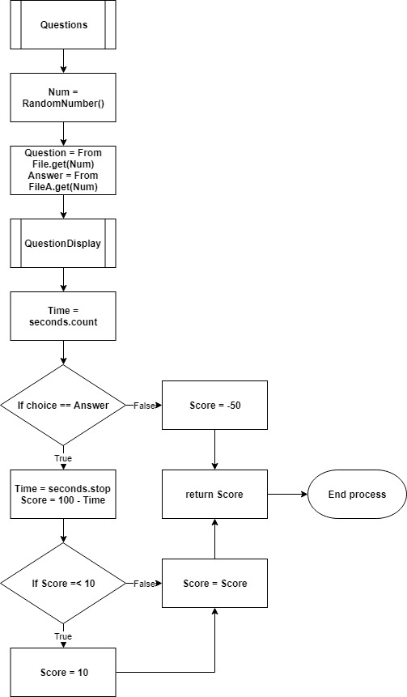

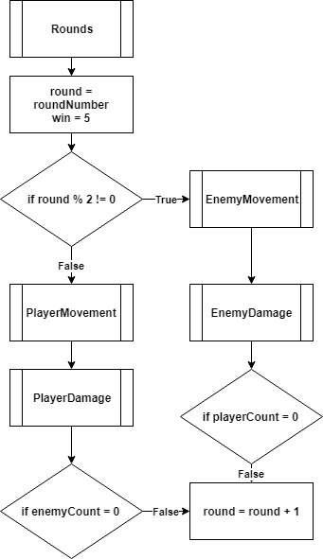

## Usability features

I will incorporate features and change different parts of the program such that it can be accessible to my target audience which are sixth formers studying maths/physics. I will consider features such as:

Using Clear English and easy instructions

I will have instructions at the beginning of the game which will guide the user through the game so that they know what to do. They will also be icons which can be hovered over to provide additional help to the item oriented around the item. For example, an icon on the question box explaining that they are given a question to work out and answer. Controls will also be shown to them and accessible in the menu. This is done so navigating through the program will be as easy as possible and no confusion is created.

The program will also be in simple English so no complicated works even though they are year 12/13, but having a simple vocabulary for the game will provide additional ease for the user.

They will also be instructions in the game showing them their objective and a Pause feature so they can reconcile with the help or leave f they wanted.

The help and instructions will pop up every time they encounter a certain event which could become annoying so there is a feature in the settings to turn this off if they are confident with the game and understand how to navigate and use it. However, this can be turned back on at any time.

Features for colour blindness

# Bibliography

Figure 1 Agile Life Cycle 3

Figure 2 Course Overview of Entire A-Level 8

Figure 3 Within the Dashboard of Sub Topics 8

Figure 4 Walkthrough Through a Sub Topic 8

1. https://www.pinterest.com/pin/631066966504836922/
2. https://2017.integralmaths.org/my
3. https://2017.integralmaths.org/course/view.php?id=27
4. https://2017.integralmaths.org/course/view.php?id=27&sectionid=681
5. https://www.examsolutions.net/a-level-maths/edexcel/
6. https://www.youtube.com/watch?v=XPv9UuWeaVw

   